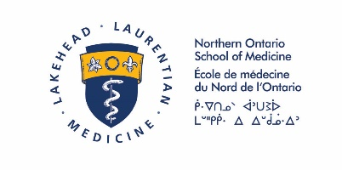

COVID-19 Personal Protection Equipment (PPE) Recommendations for NOSM Phase 2 Students in Clinical Settings
Version 3 – July 2, 2020
- These recommendations are subject to change and will be reassessed on a regular basis.
- Hospital and/or Clinic regulations and guidance will be used whenever possible and supersede these recommendations.
- It is recommended that Phase 2 students not be involved in Aerosol Generating Medical Procedures (AGMP’s) (as per hospital definitions) unless supervised closely by preceptor in a safe environment wearing appropriate Personal Protective Equipment (PPE).
- Phase 2 students should not be involved in the care of confirmed COVID patients other than virtual/telemedicine care.
- Other PPE recommendations will be determined by presence of symptoms (as per most recent Public Health definitions) and COVID-19 swab status as per the table below:

Clinical Setting | COVID-19 not suspected or negative. | Suspected or Probable COVID-19 | Confirmed COVID-19
Community/ Clinic | Surgical Mask and Eye Protection* | Droplet/Contact** | Phase 2 students not to be involved in care.
Emergency Department | Surgical Mask, Eye Protection, Gown and Gloves | Droplet/Contact** | Phase 2 students not to be involved in care.
In-Patient | Surgical Mask and Eye Protection* | Droplet/Contact** | Phase 2 students not to be involved in care.
Operating Room | Droplet/Contact** | Droplet/Contact** and follow hospital Operating Room protocols | Phase 2 students not to be involved in care.

*Some hospitals and clinics require Eye Protection in addition to Surgical Masks during all clinical encounters.
**Droplet/Contact = Surgical mask, eye protection (visor, face shield, or goggles), gown, gloves

